**R programming Bikeshare data project**

1. What are the most popular months in Chicago, Washington and New York?

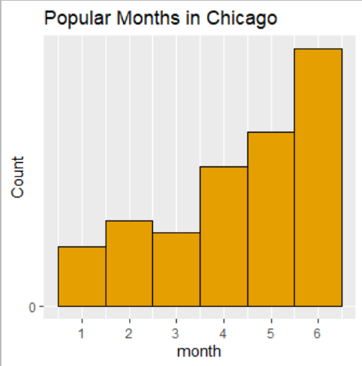 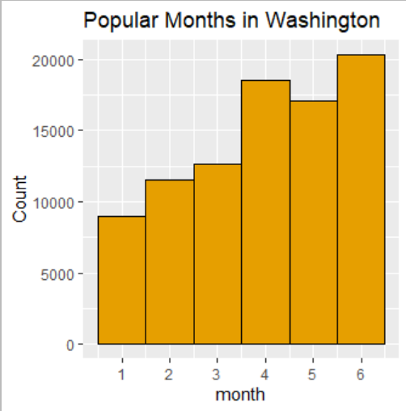 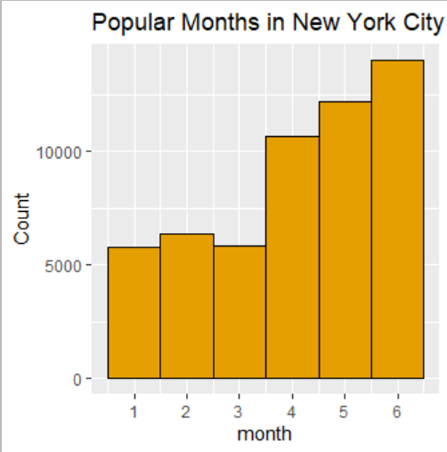

Comparing the charts, the most popular renting month is June (06) in chicago, new york and washington. There are less number of biked rented for the first three month ad this could be due to the weather. Particularly in new york city and chicago, there are less number of bikes rented in the 3rd month than the 2nd month.

1. What are the most popular weekdays in Chicago, Washington and New York?

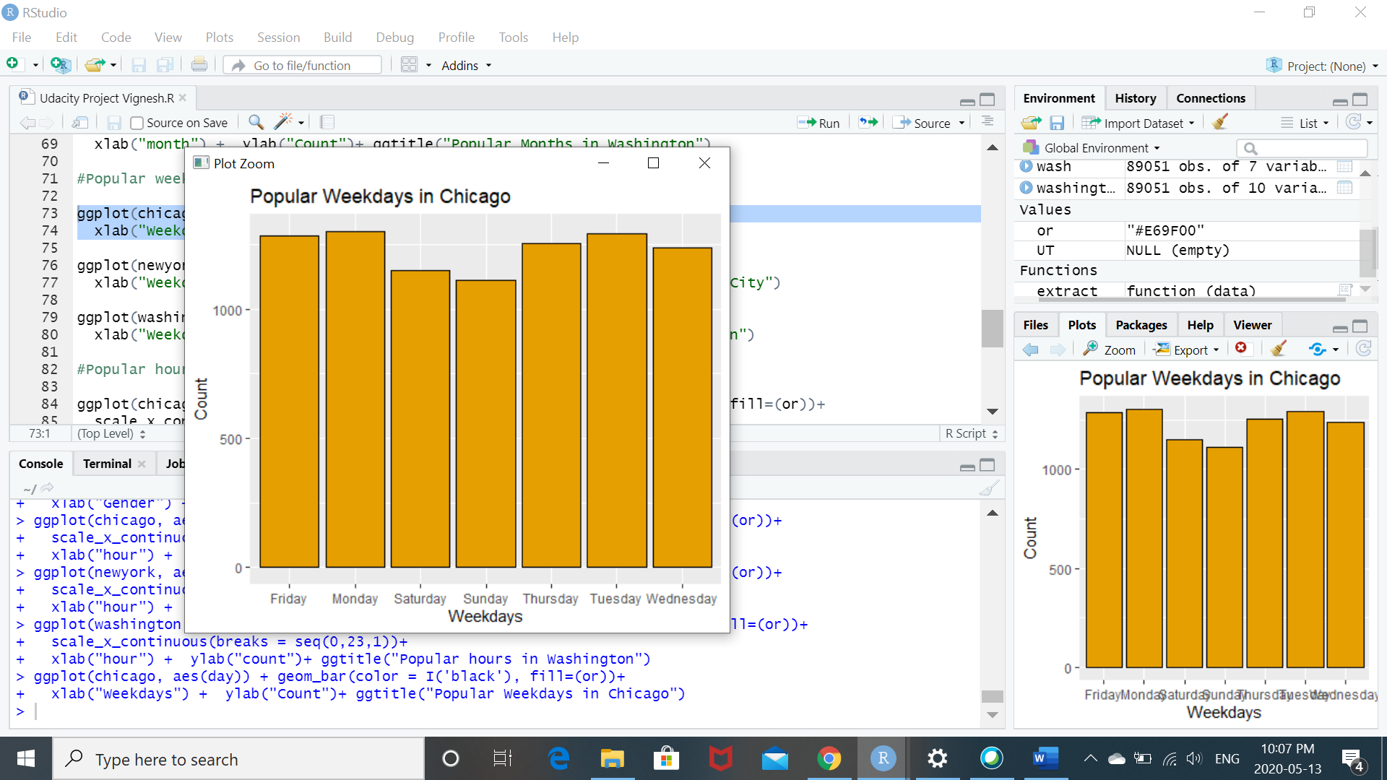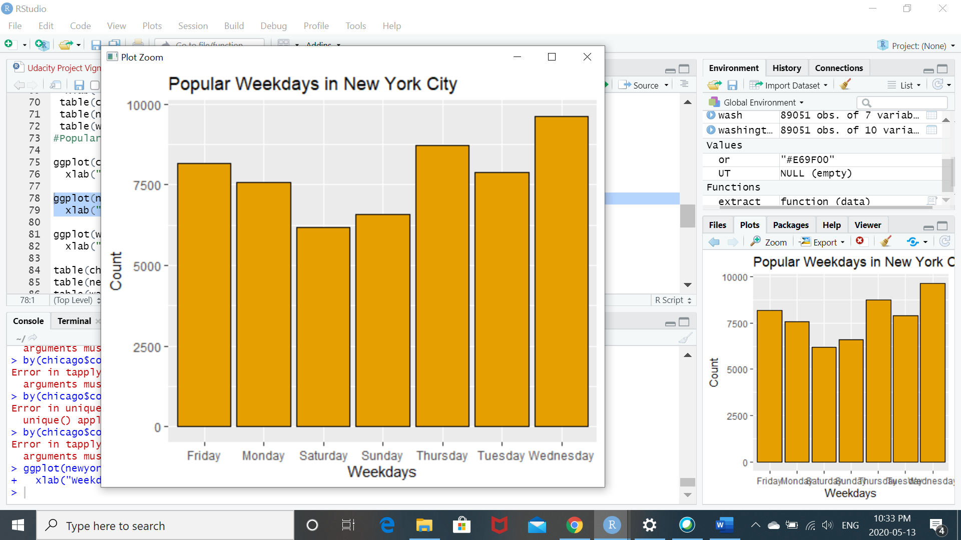

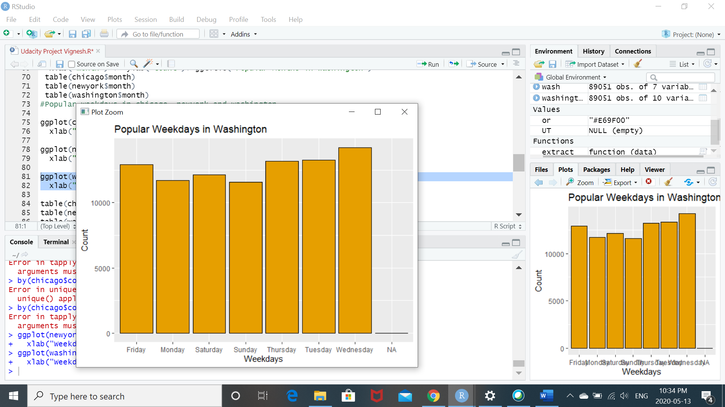

The bike renting count across different days of week from Monday to Sunday are almost even. Less number of bikes have been rented on Saturdays and Sundays as compared to other days. This could be a result of people spending weekends with the owned vehicle. Bike renting on Wednesday has been the most in Washington and New York city, whereas the highest in case of Chicago was Tuesday.

1. What are the most popular hours in Chicago, Washington and New York?

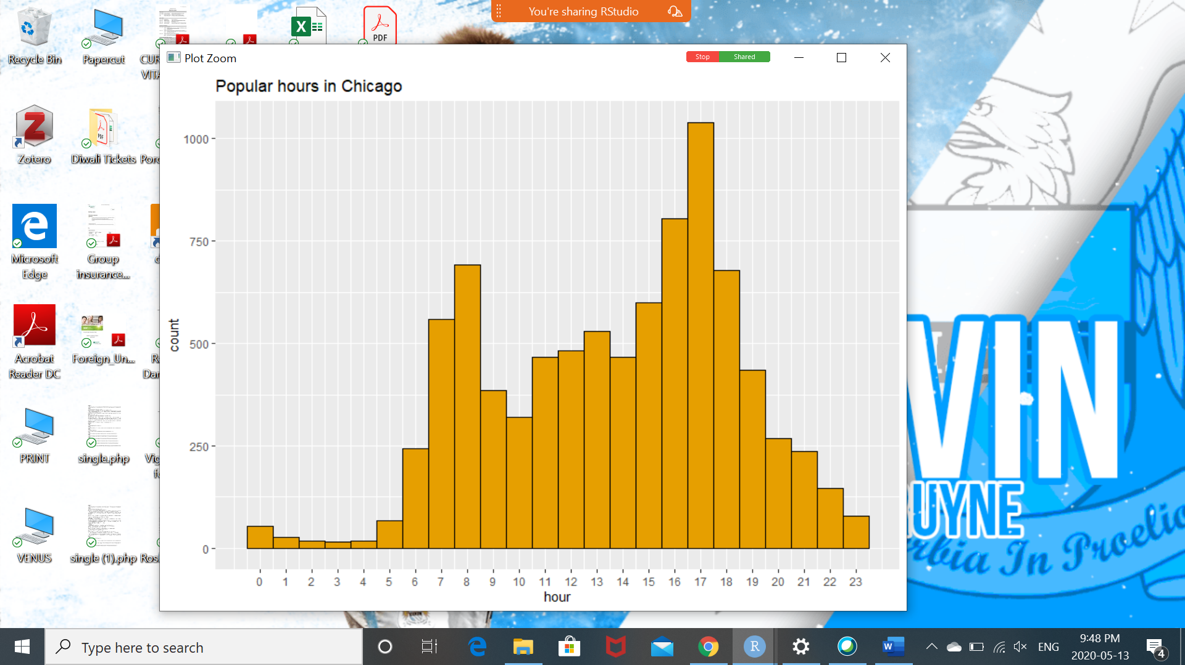 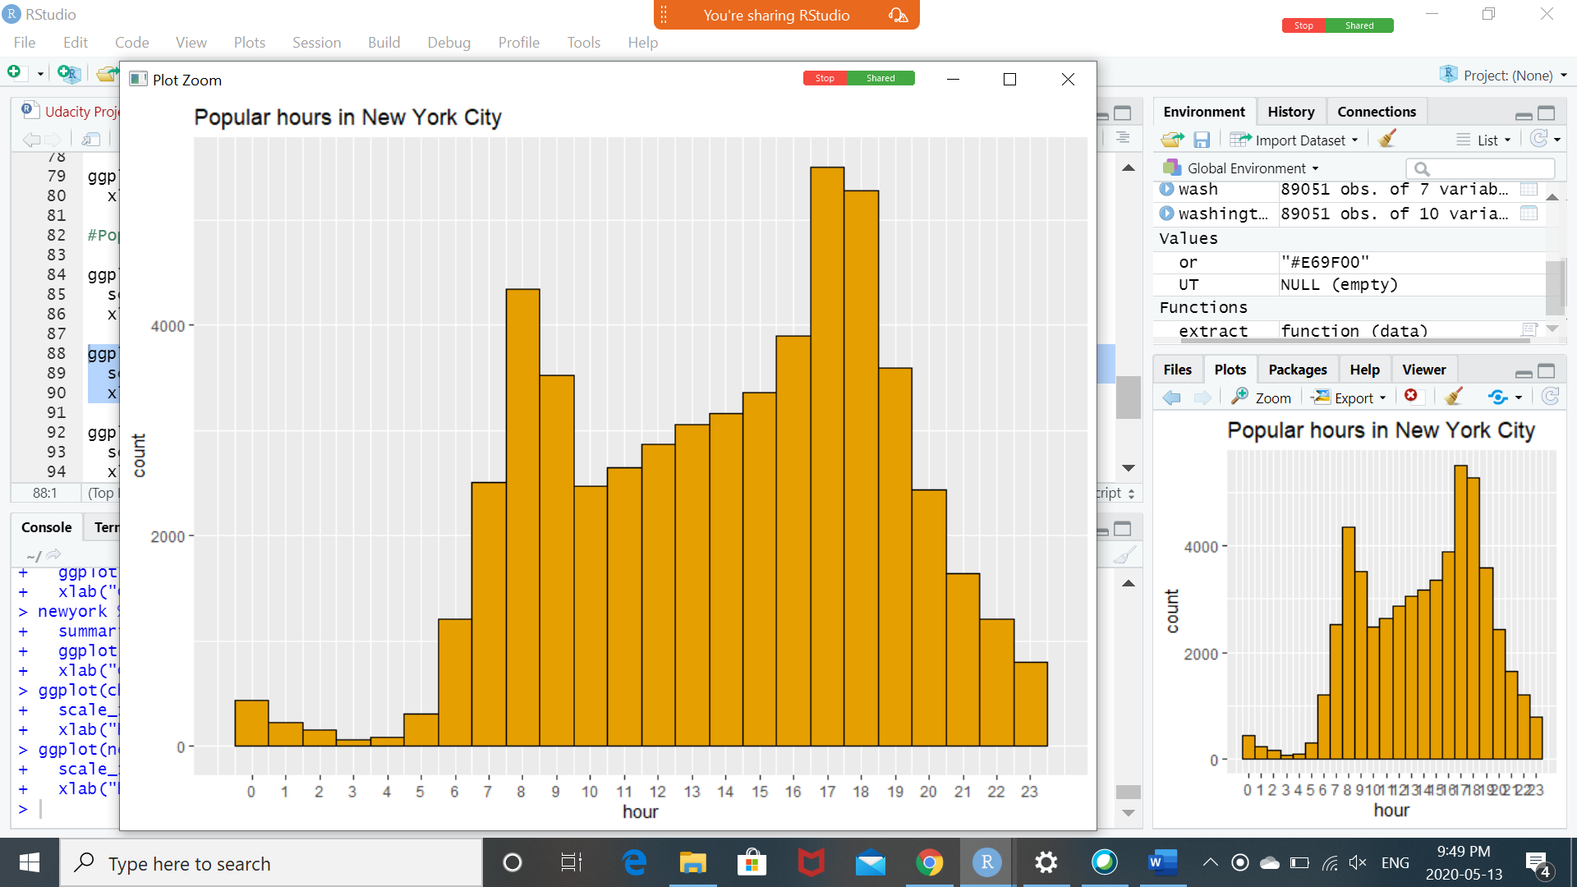

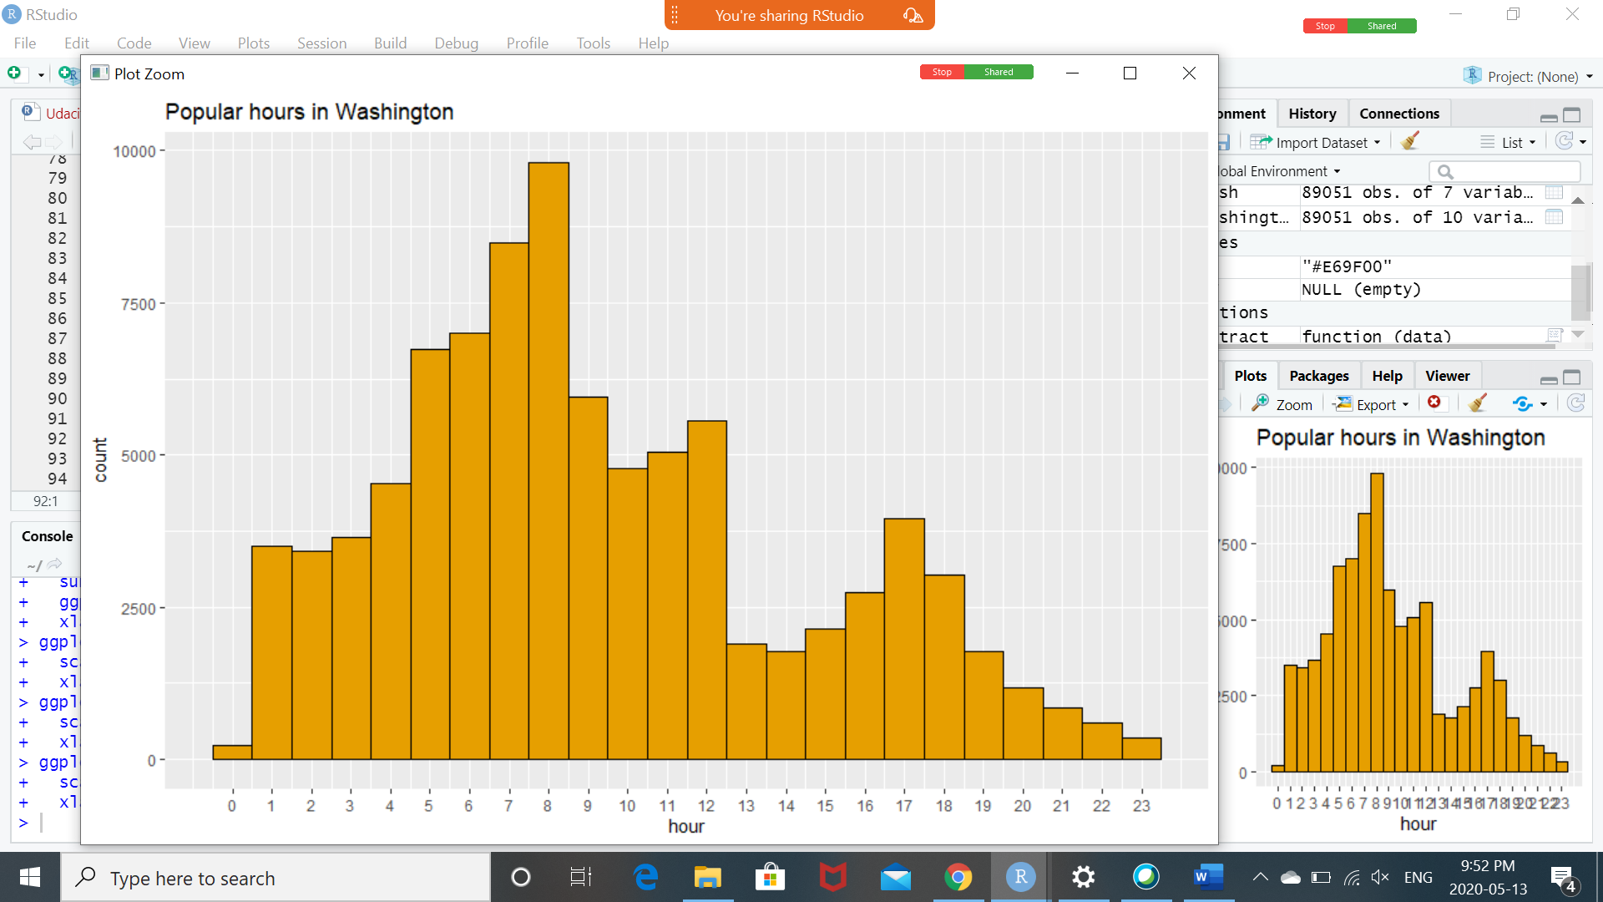

The most popular renting hours in Chicago and New York city is 17:00 hours This could be because of people renting bikes to return home after work. In Washington, the most popular renting hour was 8 am and could be a result of a lot of people renting to go to work. Least renting in Washington was observed in the night after 21 hours until 1 am. In the case of Chicago and New York city, least renting was observed from 00 hrs to 5 am.

1. What is the gender count for Chicago and New York?

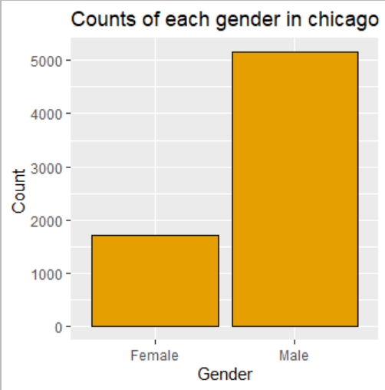 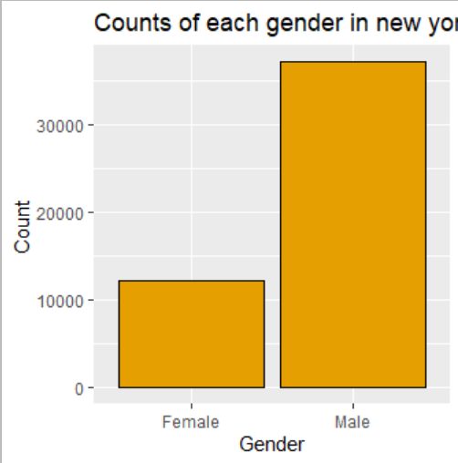

According to statistics, there are 5159 males and 1723 females renting bikes in chicago. Whereas, there are 37201 males and 12159 females renting bikes in new york. The reason might be because of new york being more populated than chicago. In general, males have been renting more bikes than females.